# Data Manipulation and Reporting with Power BI

# 1.BUSSINESS REQUIREMENT

Zomato is a restaurant aggregation and meal delivery service based in India. It is currently operating in several countries across the world. Zomato provides thorough information about numerous eateries as well as consumer reviews. Zomato's owners aim to find hidden irregularities in their company's data.

The data (sample) is currently accessible in the form of a few Excel files, each of which contains information about multiple restaurants operating in a certain continent.

The clients want to construct a consolidated and interactive Power BI report that will allow them to do the following:

1. Derive data on the total number of restaurants worldwide, including continents, countries, and cities.
2. View data on a global scale with the capacity to drill down to a granular level.
3. Derive data on the restaurants with the highest average customer ratings.
4. Discover the restaurants with the lowest average costs.
5. Filter and view information on the restaurants based on:
   * Their geographical dimensions such as continent, country, and city.
   * The service they provide, such as online ordering or reservation services.
   * The average rating slab by color.
6. Identify the restaurants with the most cuisines served.
7. Design a multi-page report that suits Zomato's theme with easy navigation across sections.
8. Allow Zomato users to be able to access this information from both a web browser and a mobile device.

# 2. DATA LOAD

1. Click on Get data in Home tab, select the data one by one and load it by clicking on transform data.

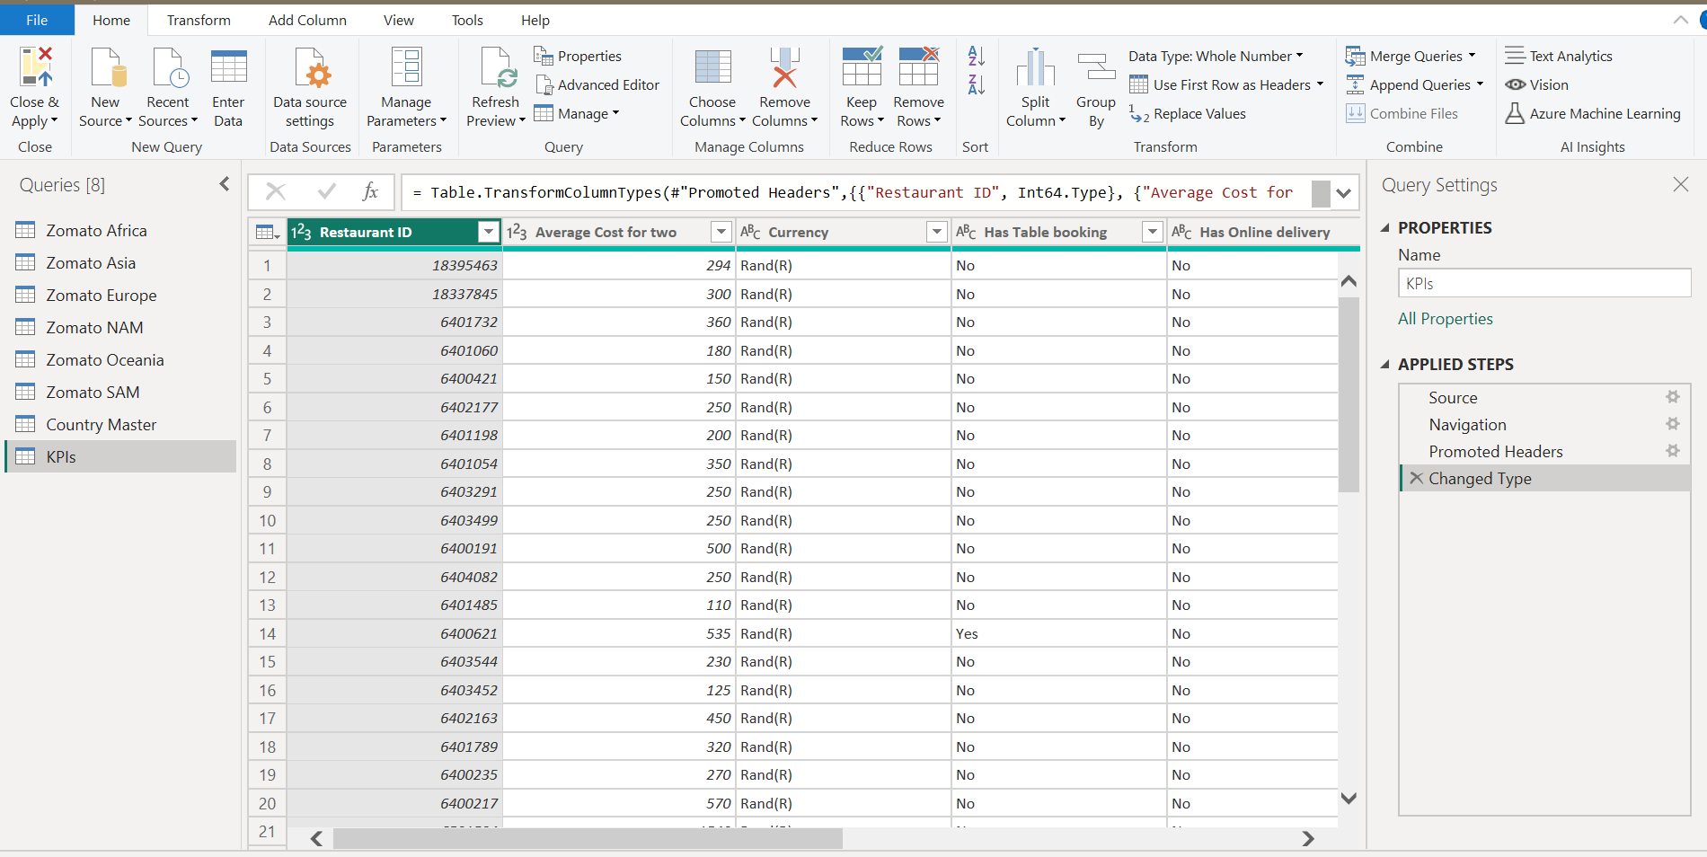

# 3.DATA TRANSFORMATION

# 3.1. Append tables

* We need to create a new table “Zomato Global” for which we need to Append the data by clicking on Append queries – Append queries as new.

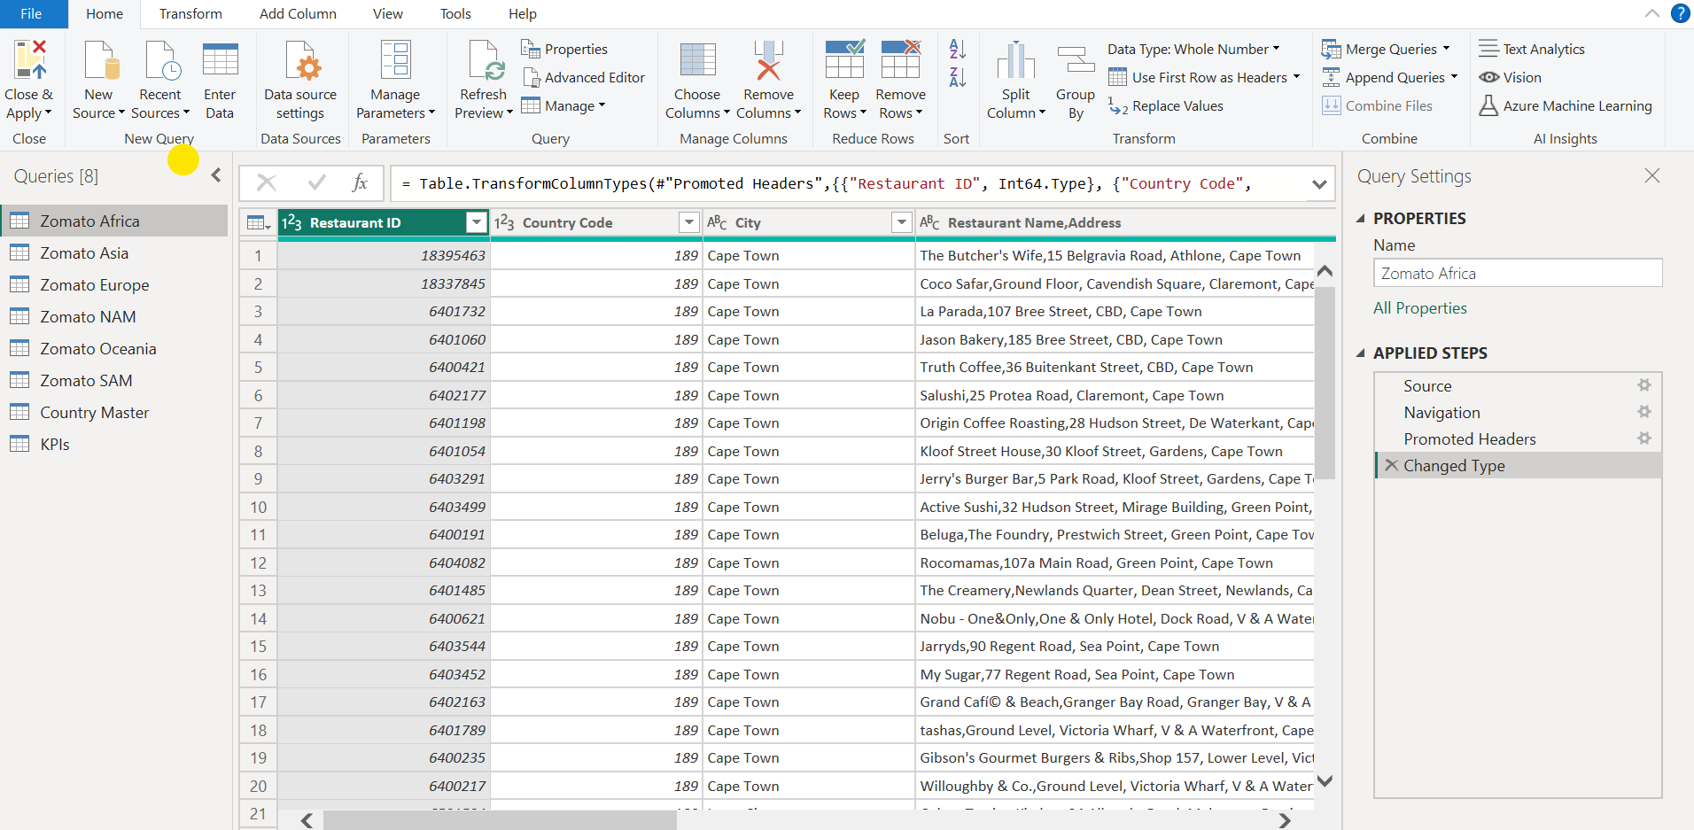

* Select the Continents Tables which we need to append and click on ok, this would create a new table

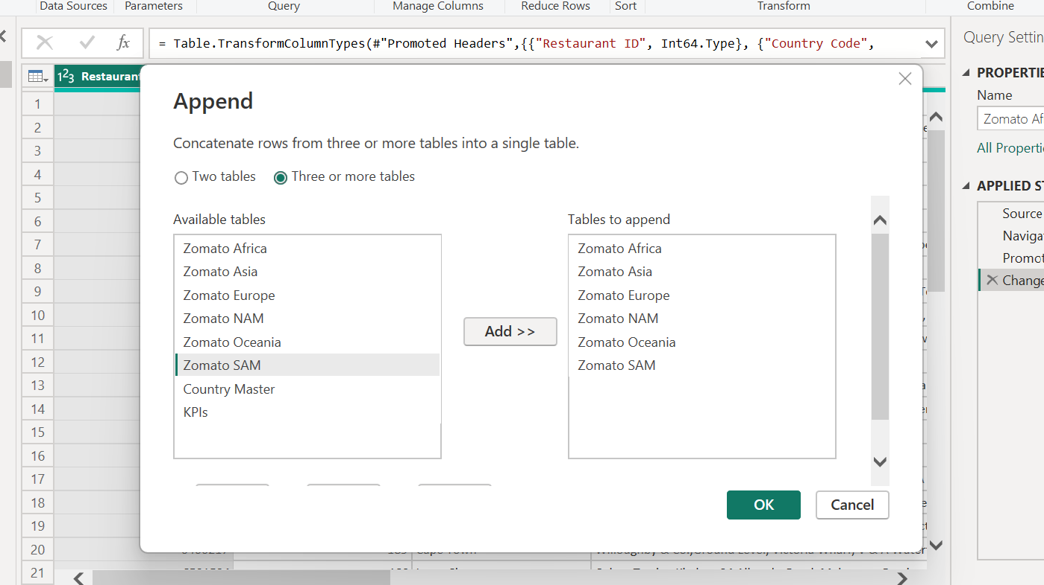

* Disable Load of the individual regions table.

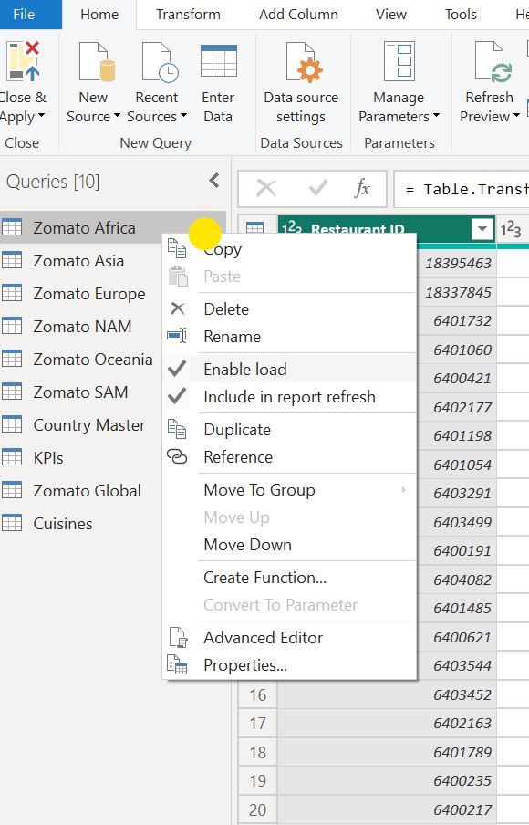

* Rename the new file created as Zomato Global.

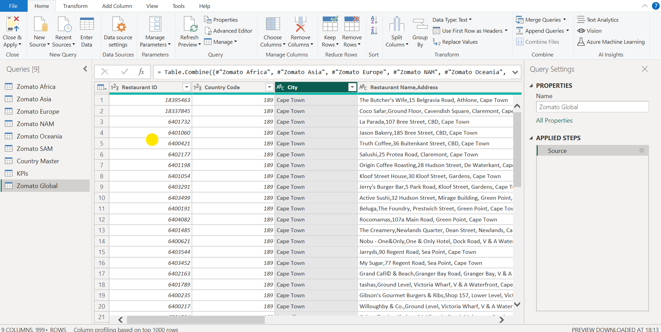

# 3.2. Zomato Global

* Make correction in City value names. For which Right click on City Column and select Replace Values.

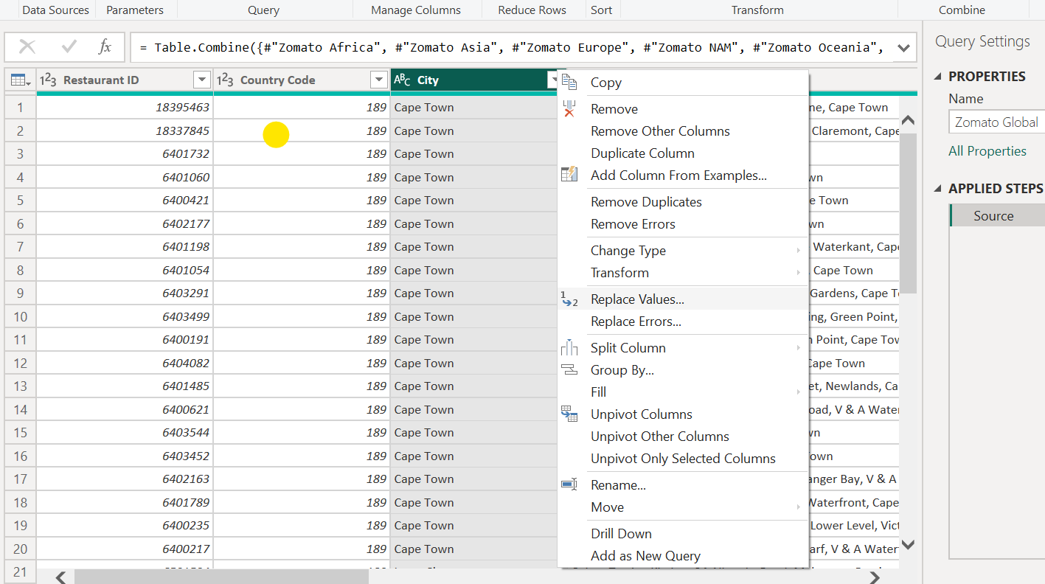

* Example – Replaced – Ûástanbul with Istanbul:

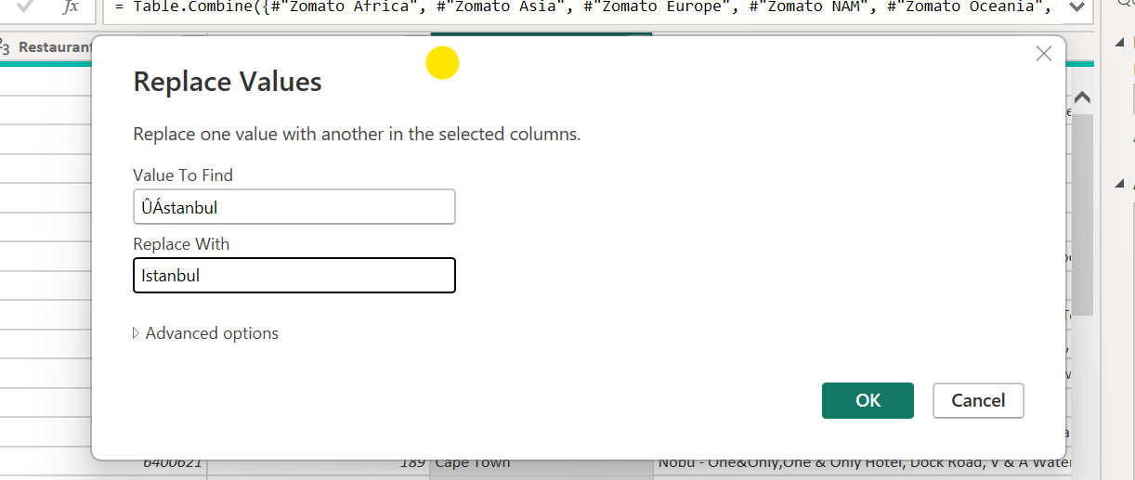

* Remove columns which are not in use by clicking on Remove Columns in Home Tab.
* Example removing Locality Verbose column:

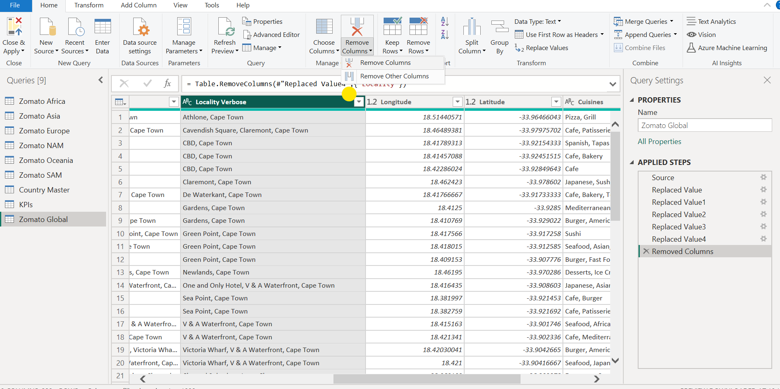

* Create two separate columns to display Restaurant Name & Restaurant Address. Click on Split Column in Home Tab and select By Delimiter - Left-most delimiter

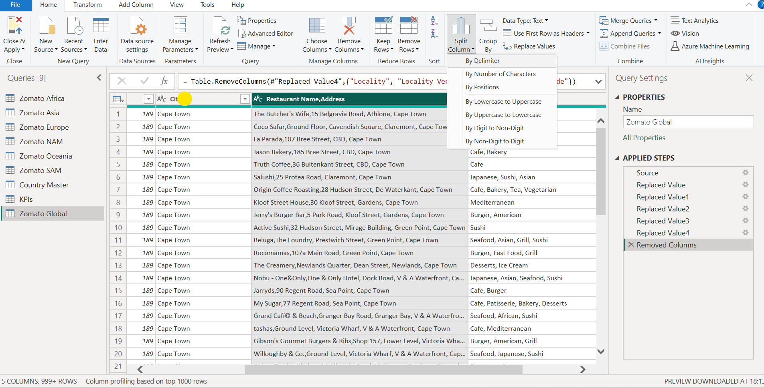

* Rename the new columns as Restaurant Name & Restaurant Address

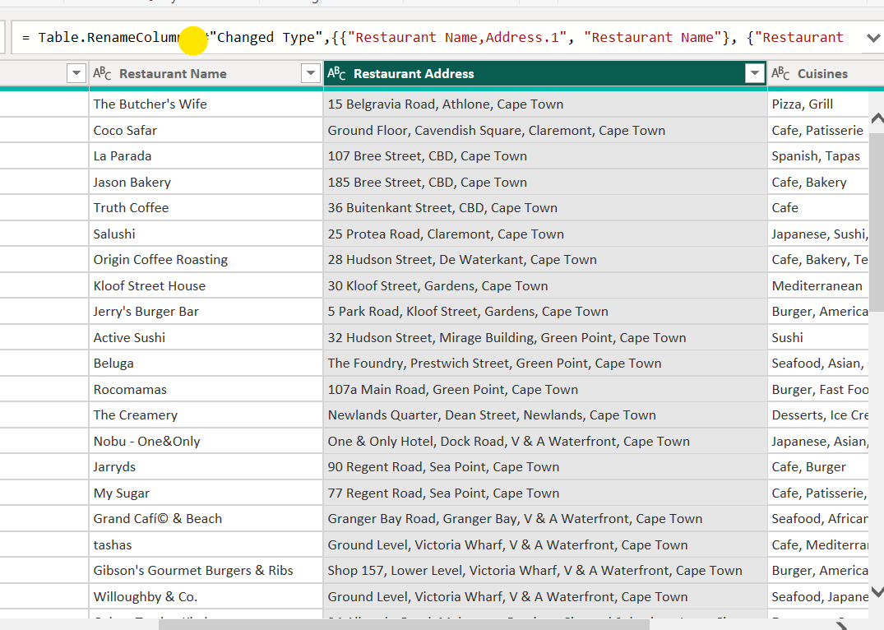

# 3.3. Cuisines

* Create Duplicate Zomato Global Table & Rename it to Cuisines.

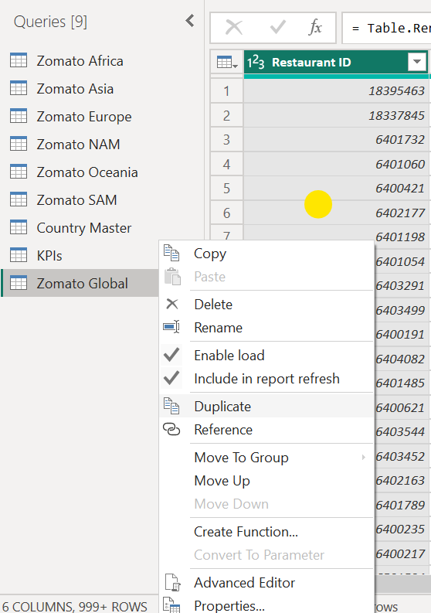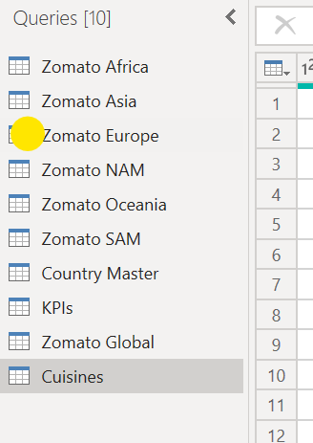

* Remove other columns which are not required by Clicking on Remove columns in Home Tab:

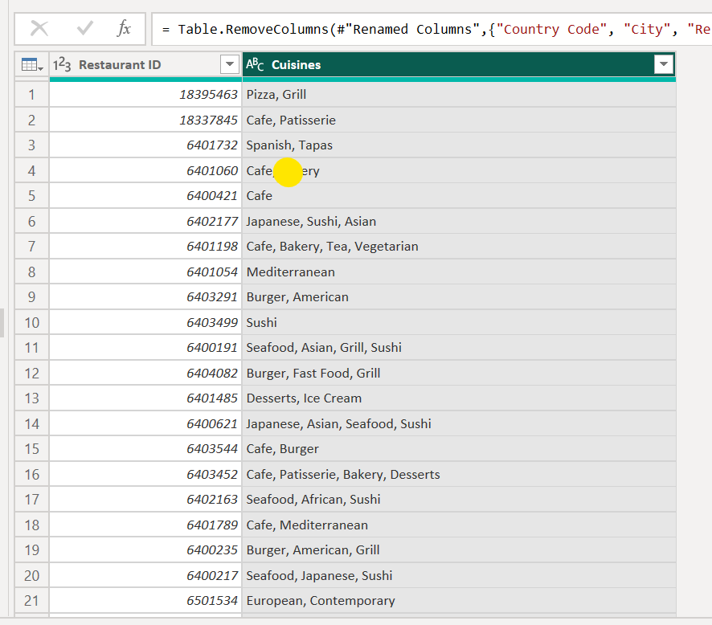

* Create Separate columns for each Cuisine as we need individual Cuisine count. Go to Split Column – By Delimiter & select – Each occurrence of the delimiter.

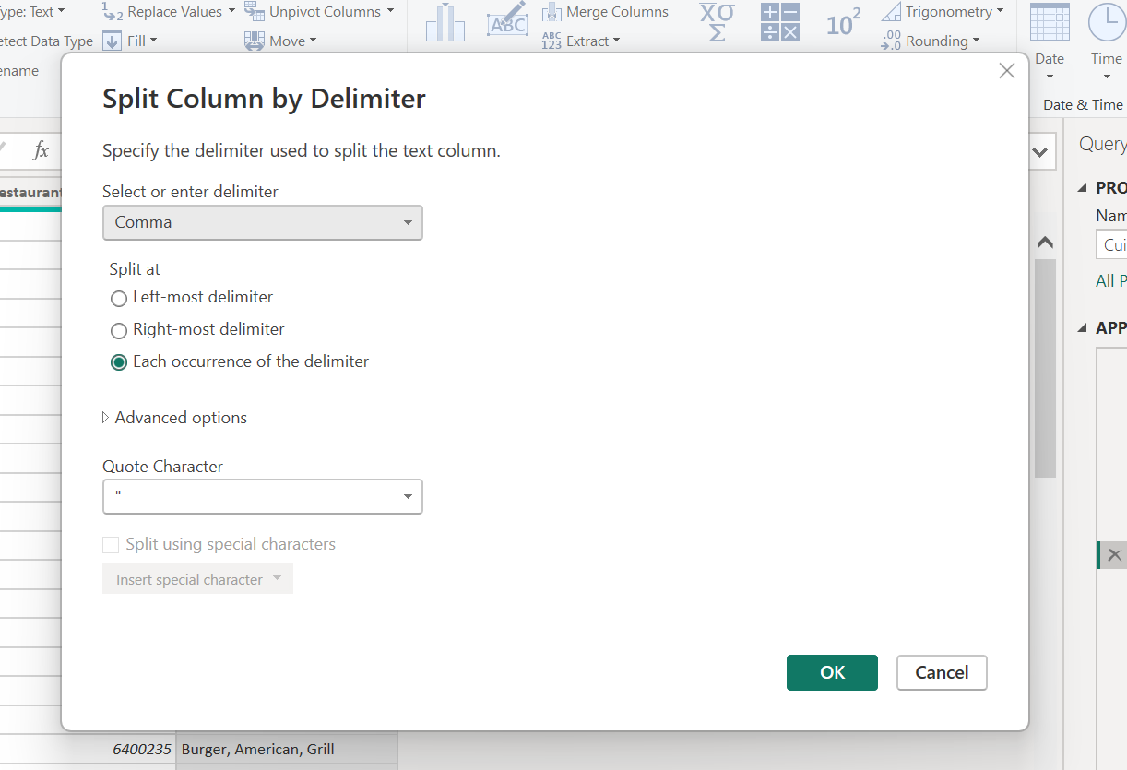

* Upon Split, we would get data in Wide Format, to convert it into proper format i.e. Long Format we would use Unpivot Columns function.

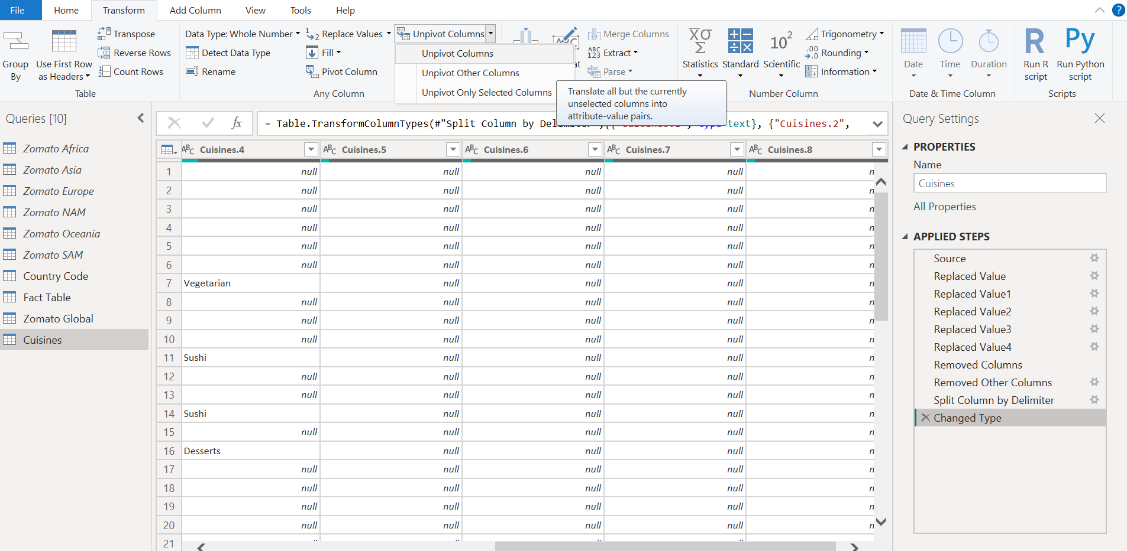

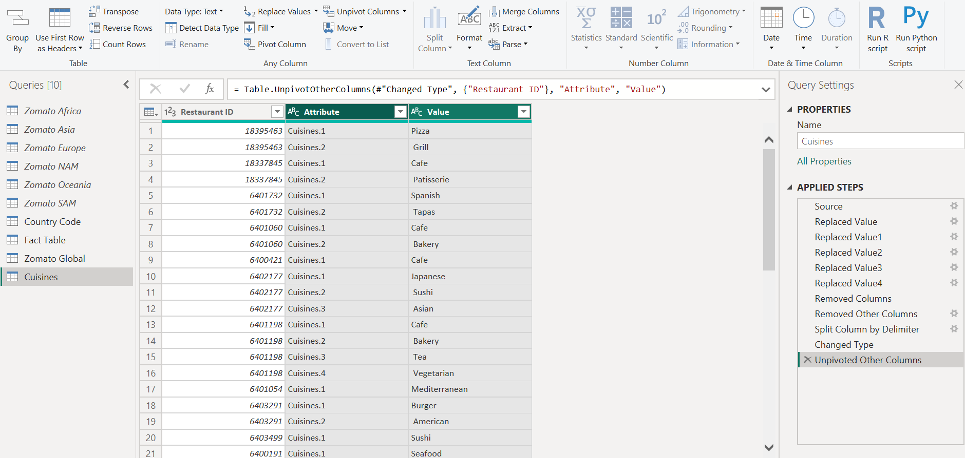

* Remove Attribute column and rename Value as Cuisines & Trim data to get it in proper format

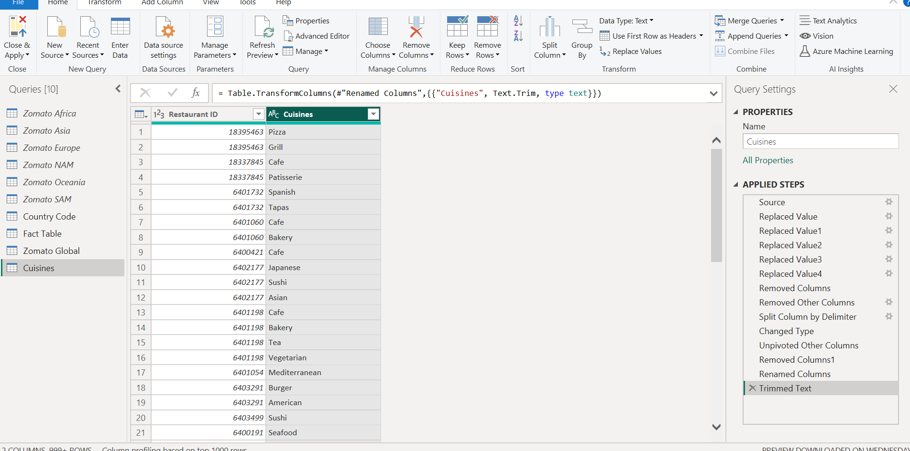

# 3.4. Country Code

* Rename Country Master to Country Code.
* Remove Null values by clicking Remove rows in Home tab and selecting Remove Blank rows.

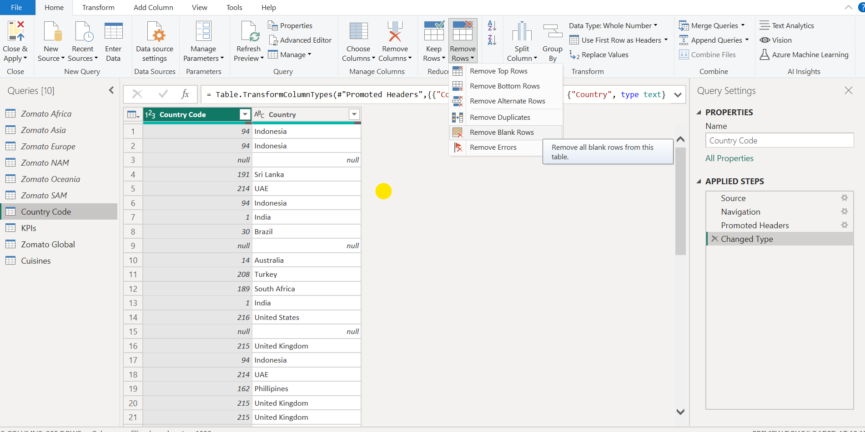

* Remove the duplicate values to get a unique list of country code and country.
* Click on Remove Rows in Home Tab & select Remove Duplicates

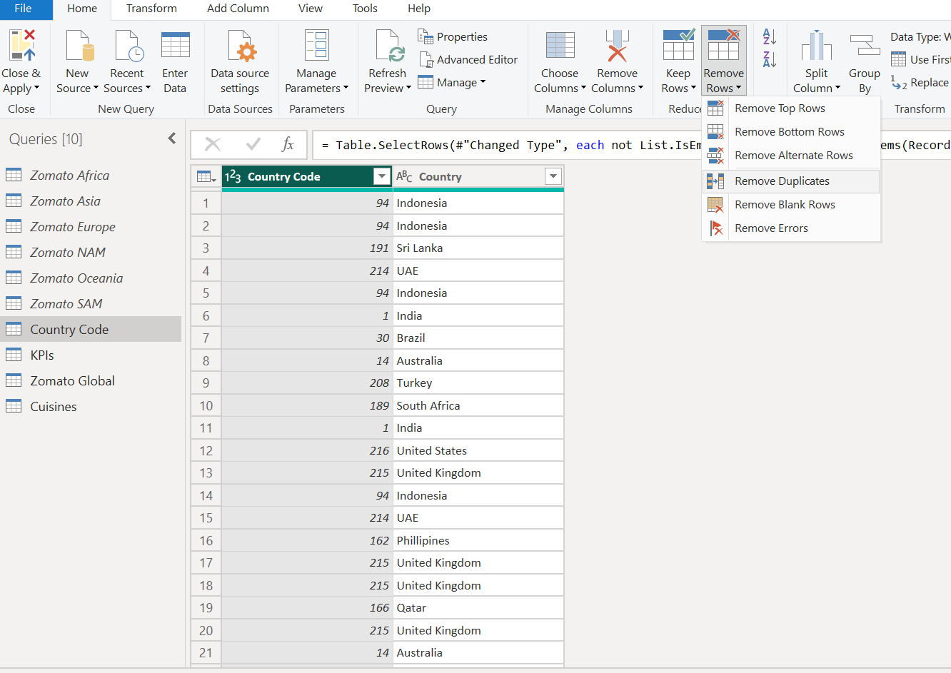

* Country-code is a dimension table hence it must include only unique and non-blank values

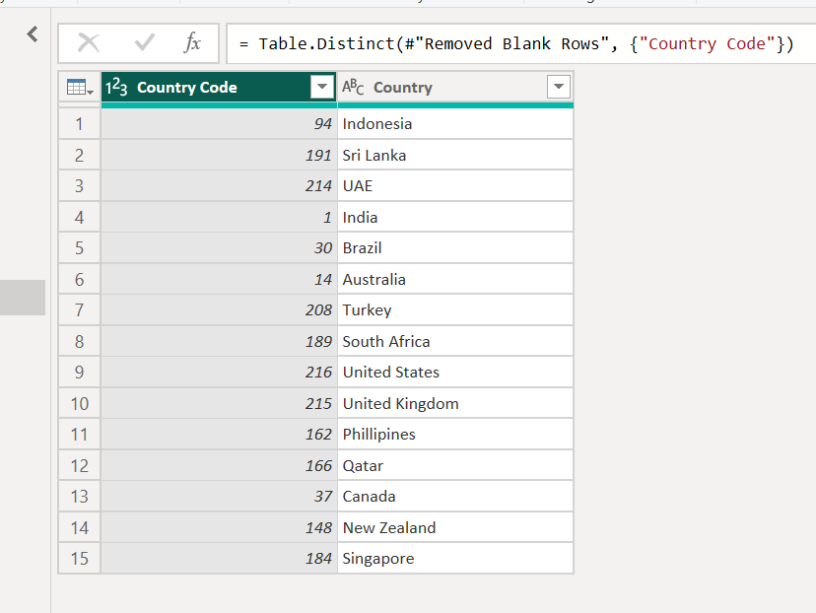

# 3.4. KPI Table

* Rename KPI Table to Fact Table

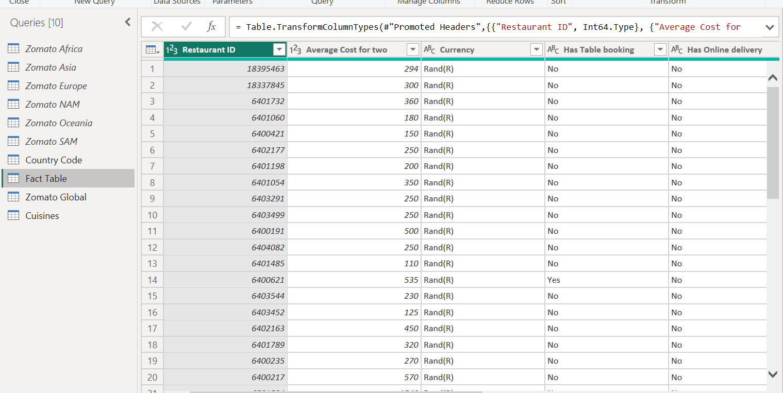

# 4.DATA TRANSFORMATION

We can see how the tables are connected to each other.

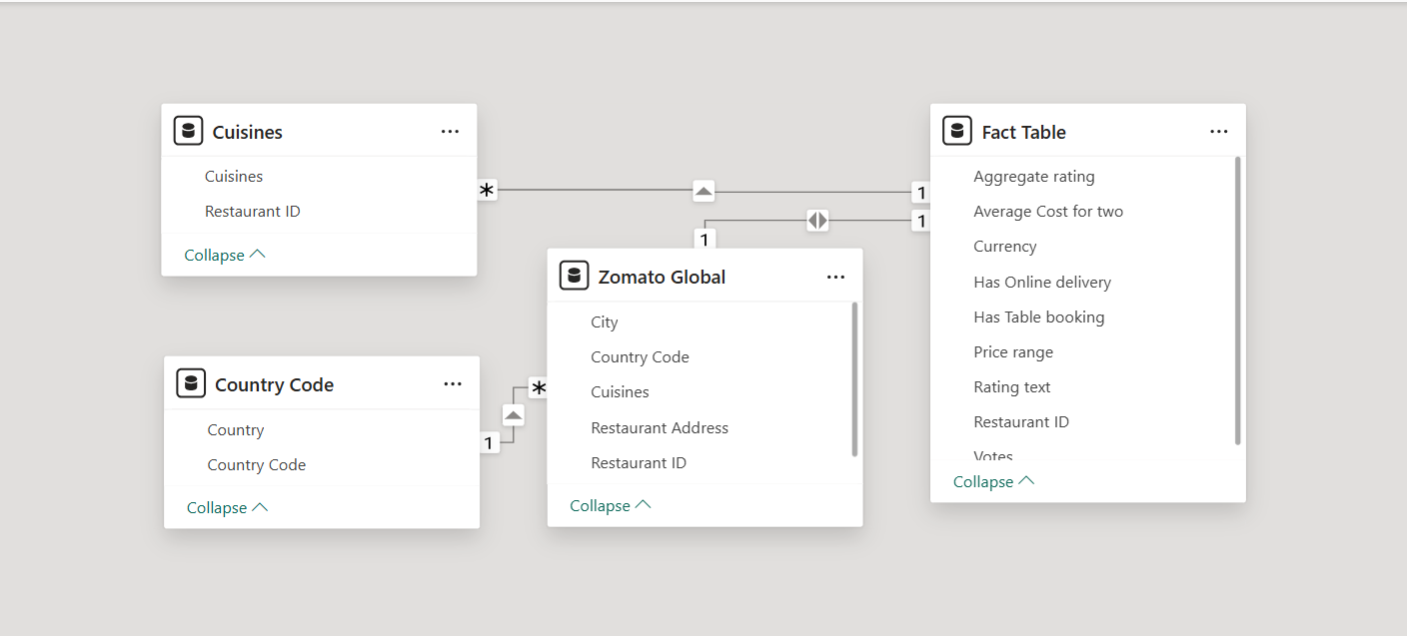

# 5.DAX – Data Analysis Expression

# 5.1. Calculated Columns

* Rating Colour Column to be created to display different colours as per Average rating
* In Table view click on Fact Table and in Table tools click on New column

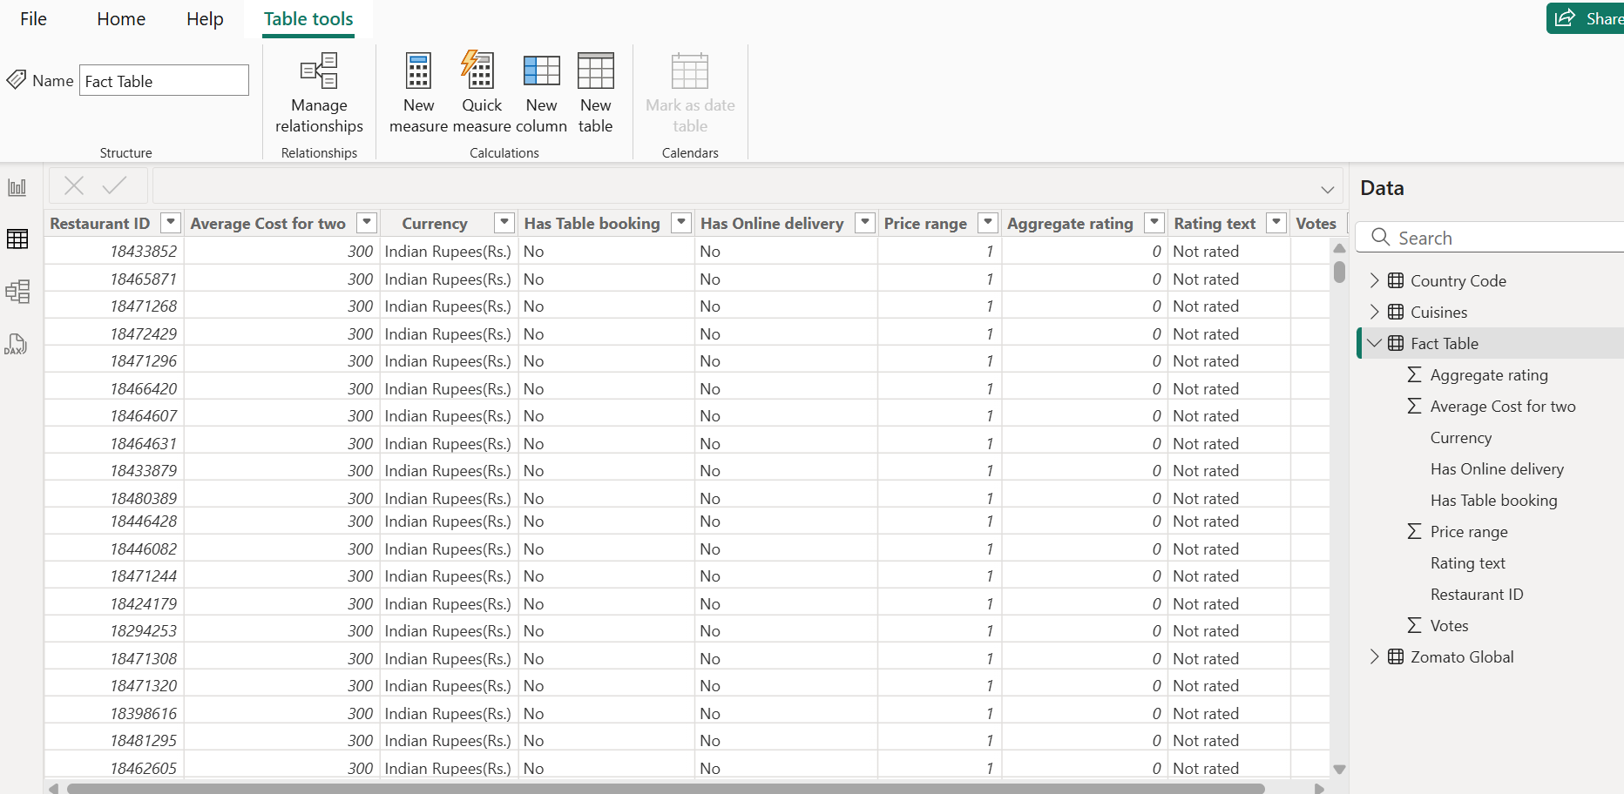

* DAX Formula to be used :

Rating Colour = SWITCH(TRUE(),'Fact Table'[Aggregate rating]>=4.5,"Dark Green", 'Fact Table'[Aggregate rating]>4, "Green", 'Fact Table'[Aggregate rating]>=3.5, "Yellow", 'Fact Table'[Aggregate rating]>=2.5, "Orange", 'Fact Table'[Aggregate rating]>=1.8, "Red", 'Fact Table'[Aggregate rating]<=1.7, "Blue")

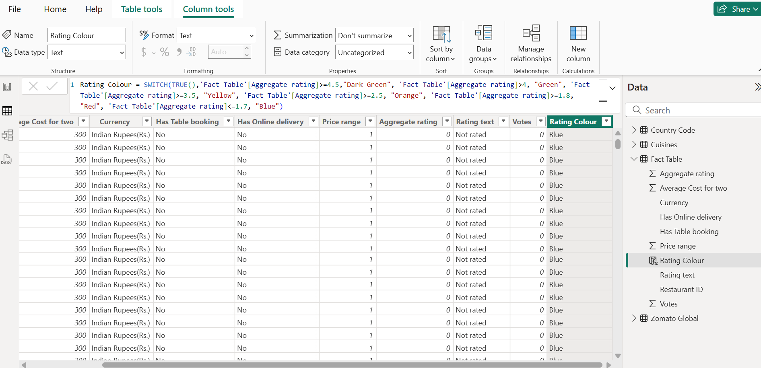

# 5.2. Calculated Measure

* Add new measure to Zomato Global to get number of restaurants, to Fact Table to get Average cost & average rating & to Cuisines to get cuisine count.

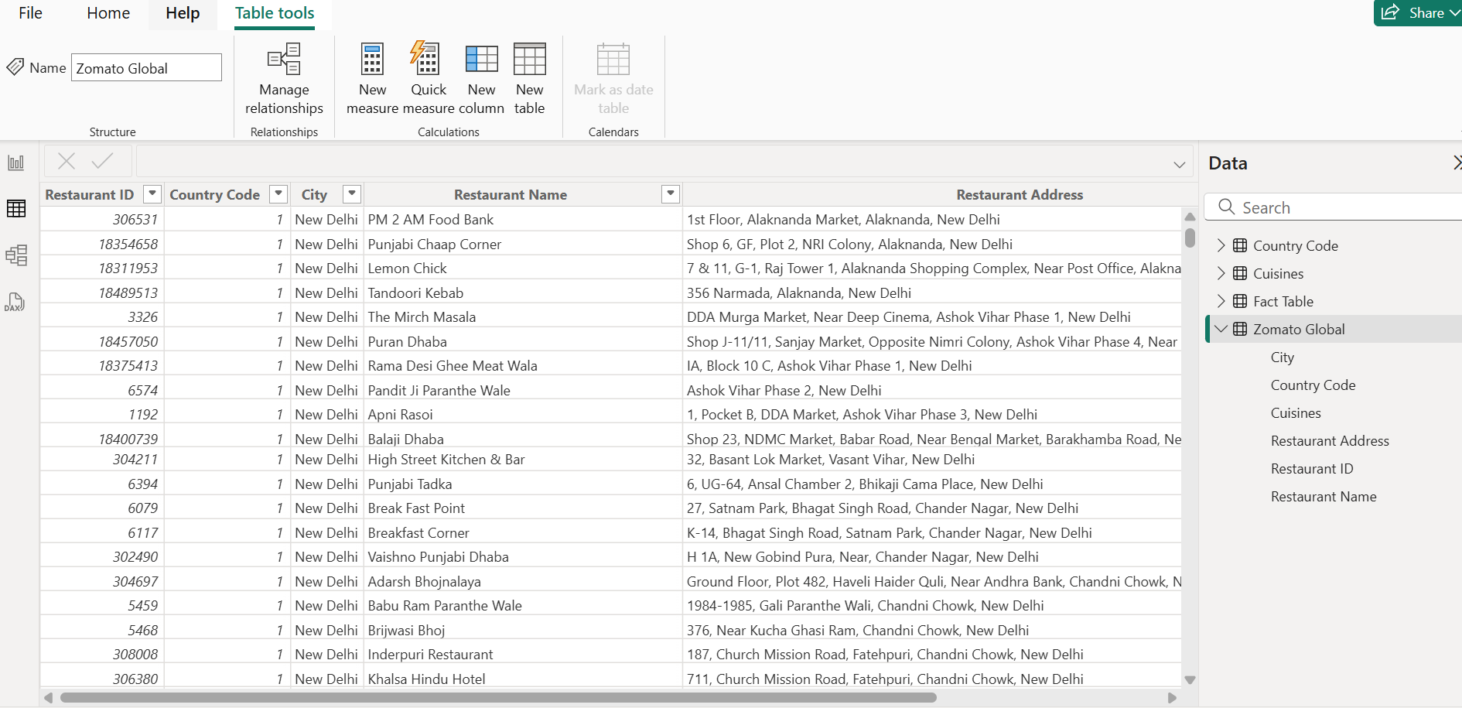

* Restaurant Count

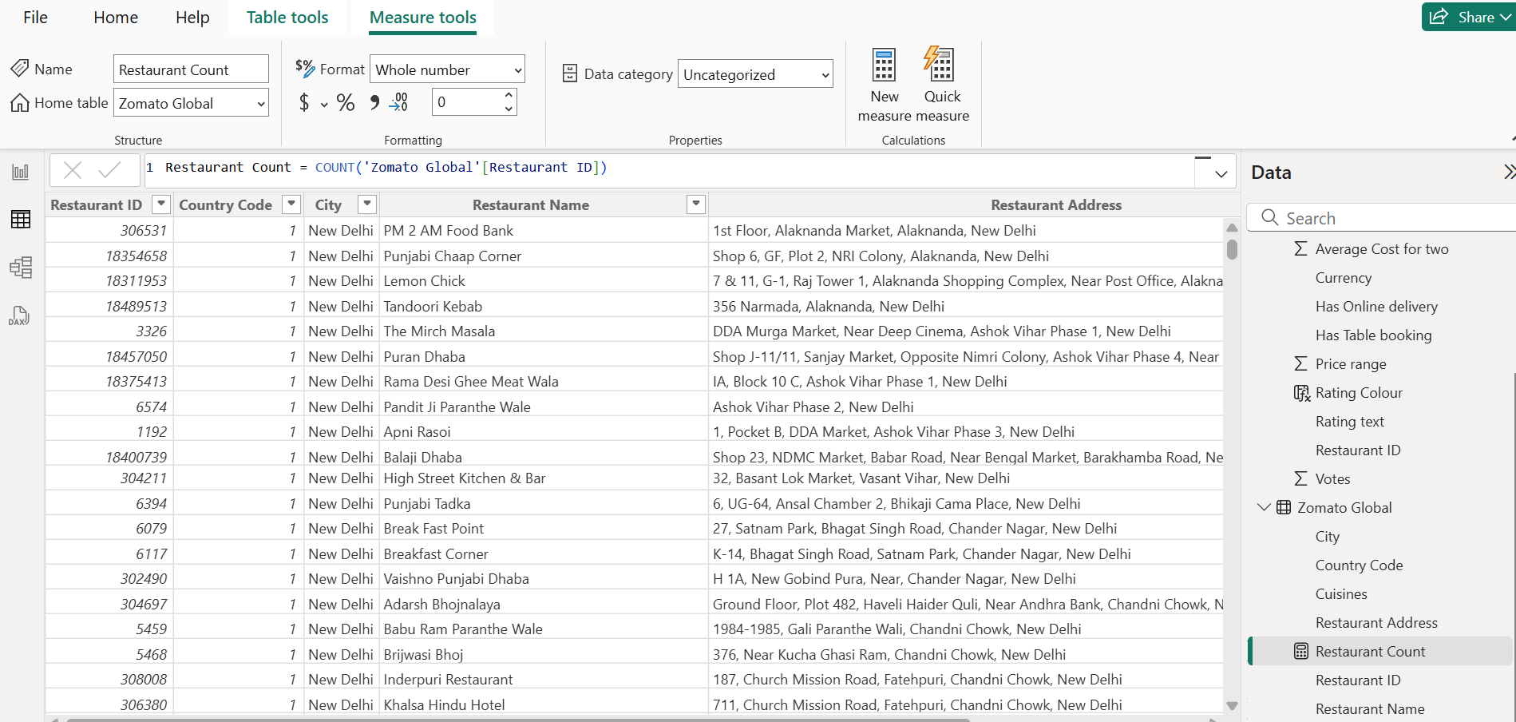

* Average Cost

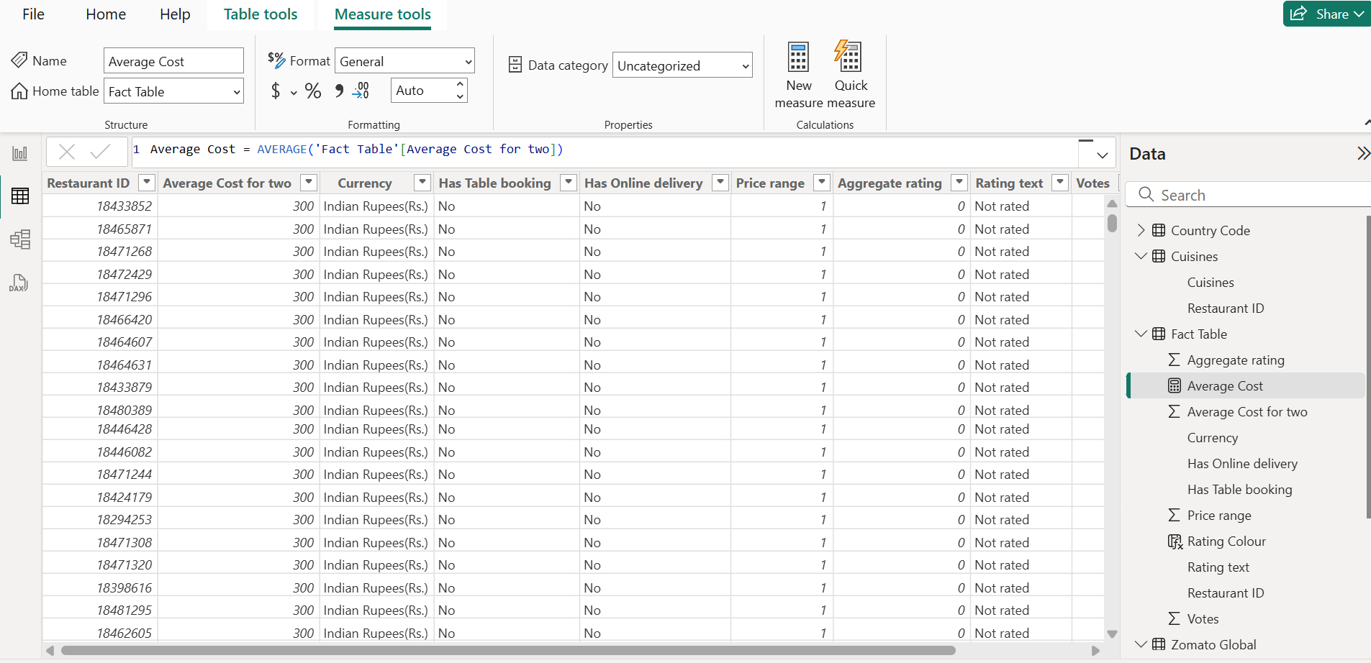

* Average Rating

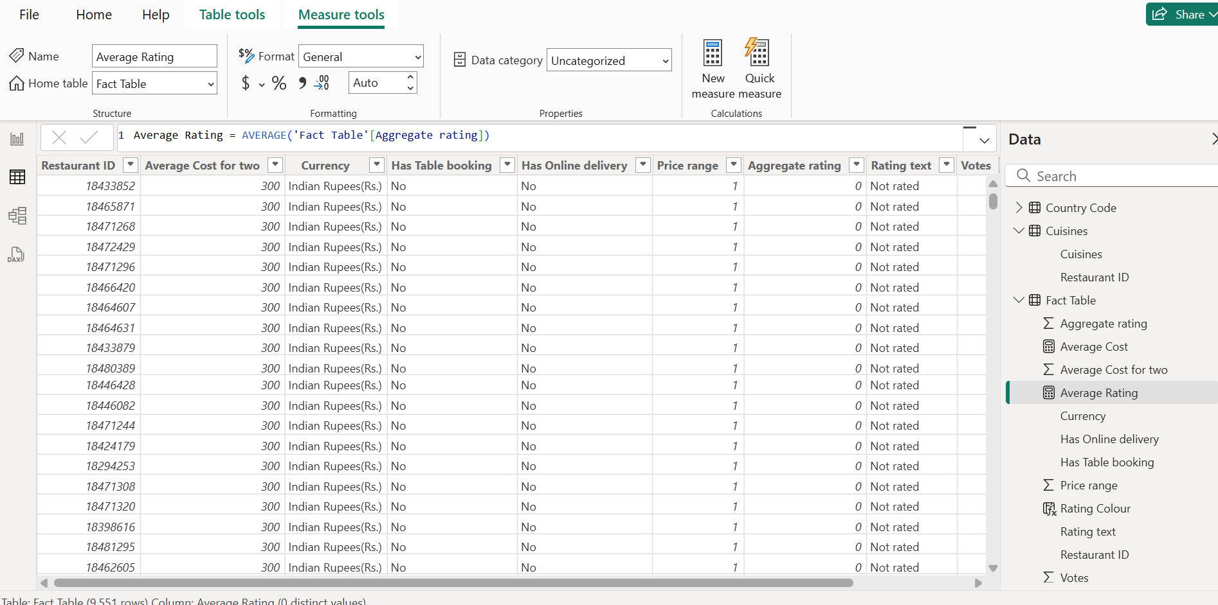

* Cuisine Count

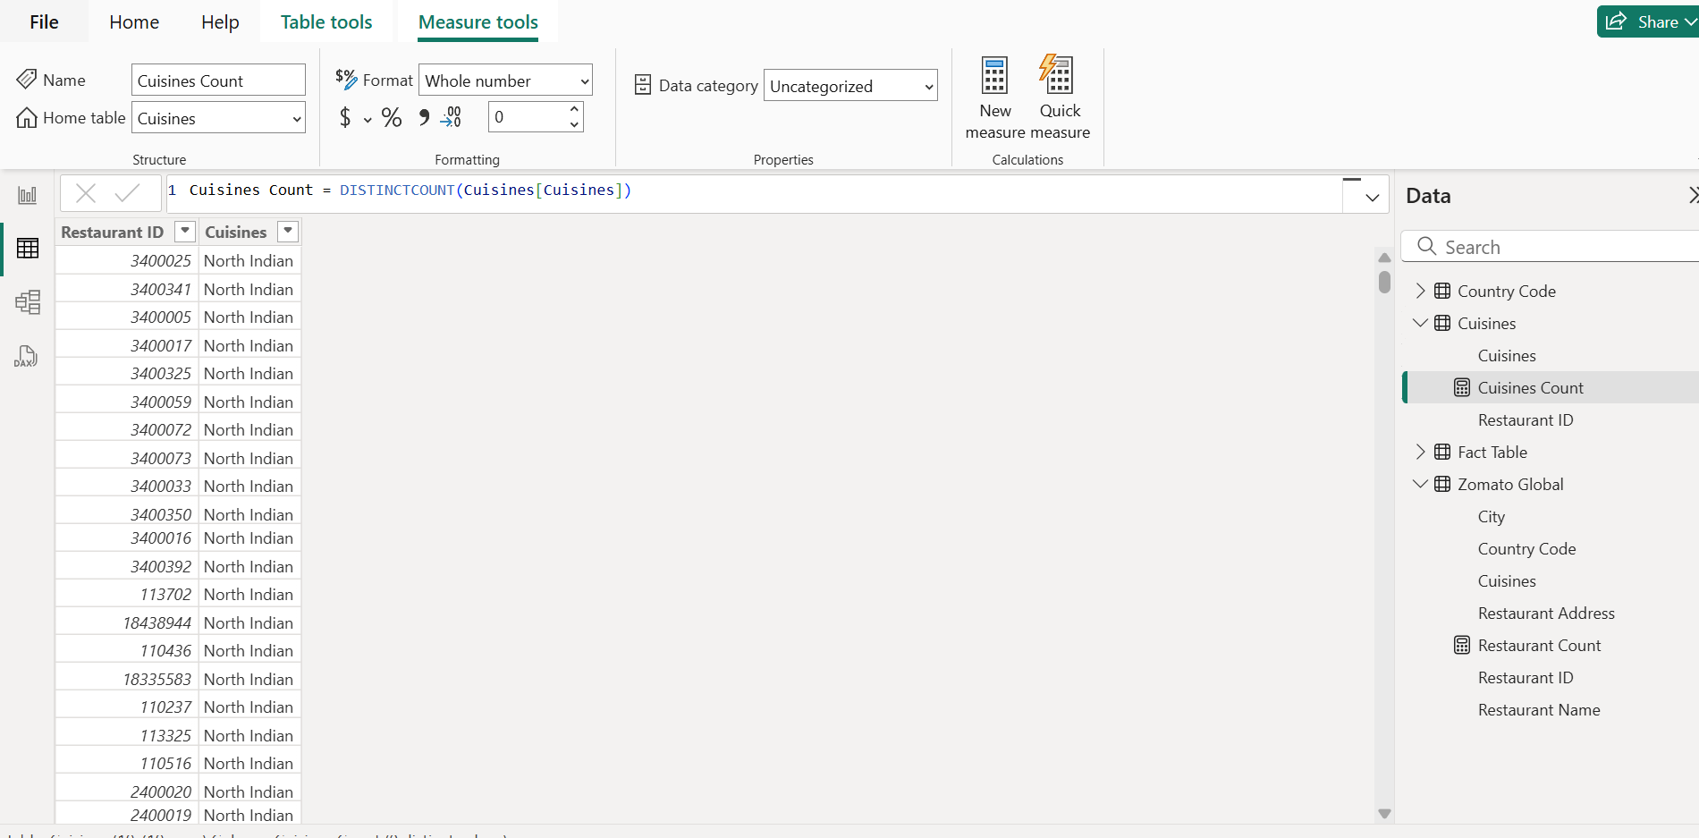

# 5.3. Continent Column

* In Country Code table click on new Column & mention below query to map Country & Continent.

Continent = SWITCH(TRUE(),'Country Code'[Country] IN {"India", "Sri Lanka", "UAE", "Indonesia", "Phillipines", "Qatar", "Singapore", "Turkey"}, "Asia", 'Country Code'[Country] IN {"United States", "Canada"}, "North America", 'Country Code'[Country]= "Brazil", "South America", 'Country Code'[Country] IN {"Australia", "New Zealand"}, "Australia",'Country Code'[Country] = "United Kingdom", "Europe",'Country Code'[Country]= "South Africa", "Africa", "Others")

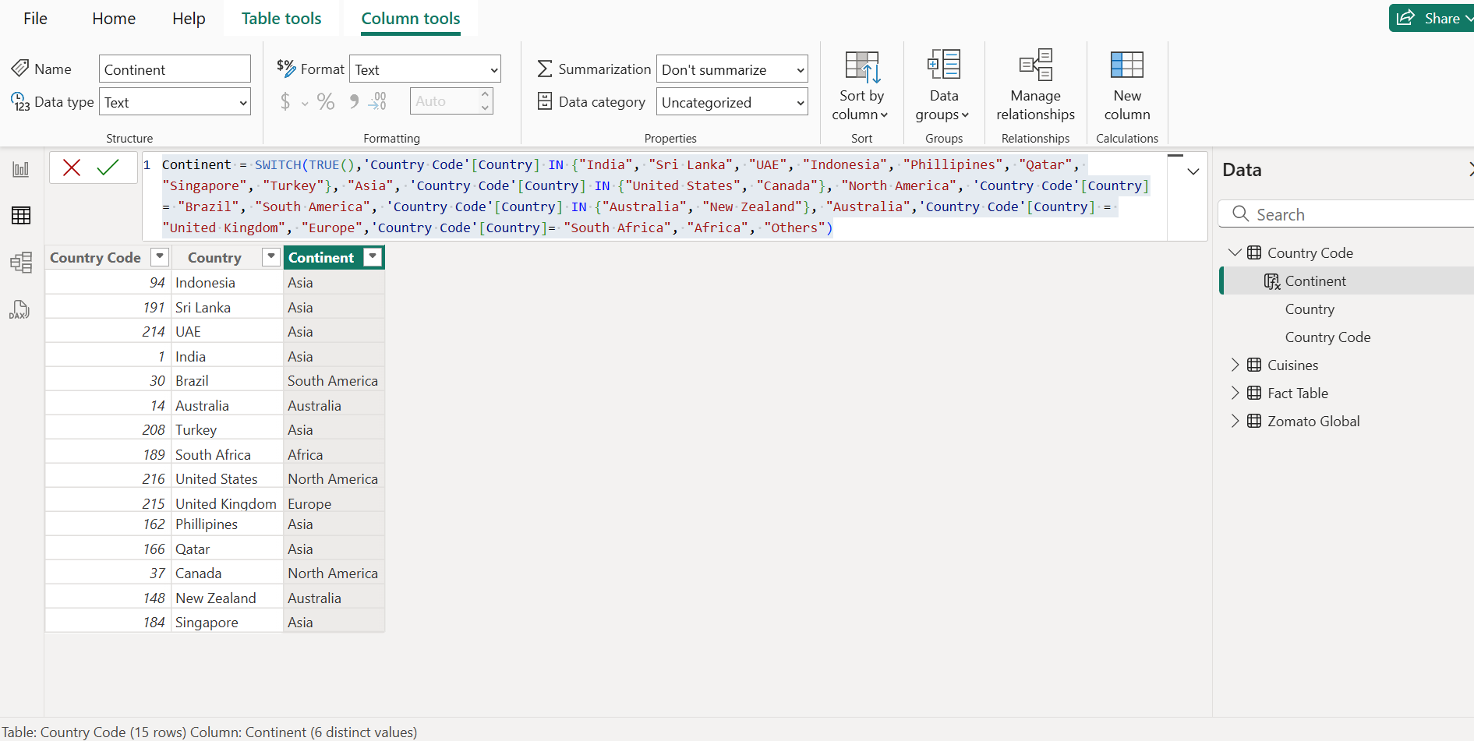

# Data Visualization & Reporting

* Derive data on the total number of restaurants worldwide, including continents, countries, and cities.

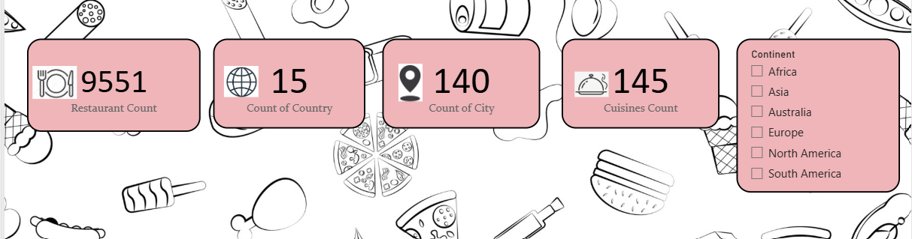

* View data on a global scale with the capacity to drill down to a granular level :

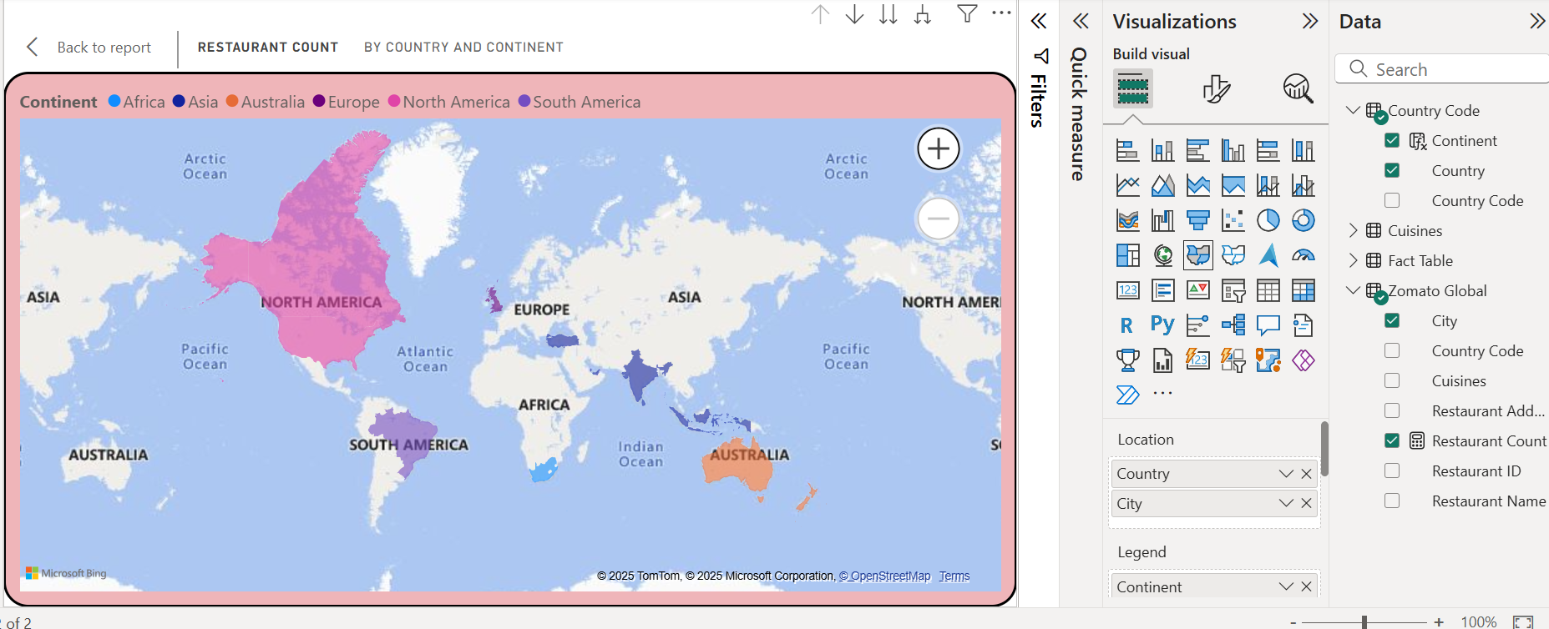

* Restaurants with Highest Average customer rating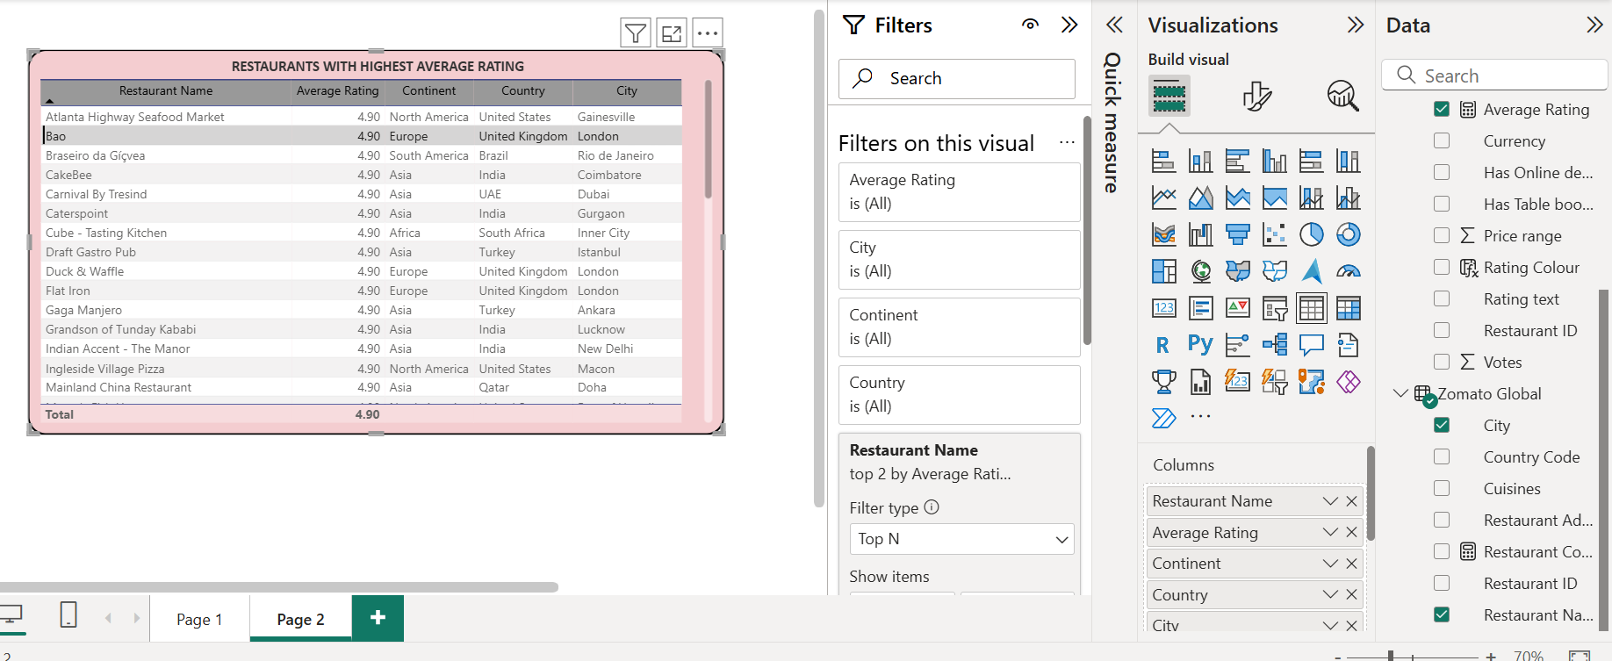
* Restaurants with the lowest average costs

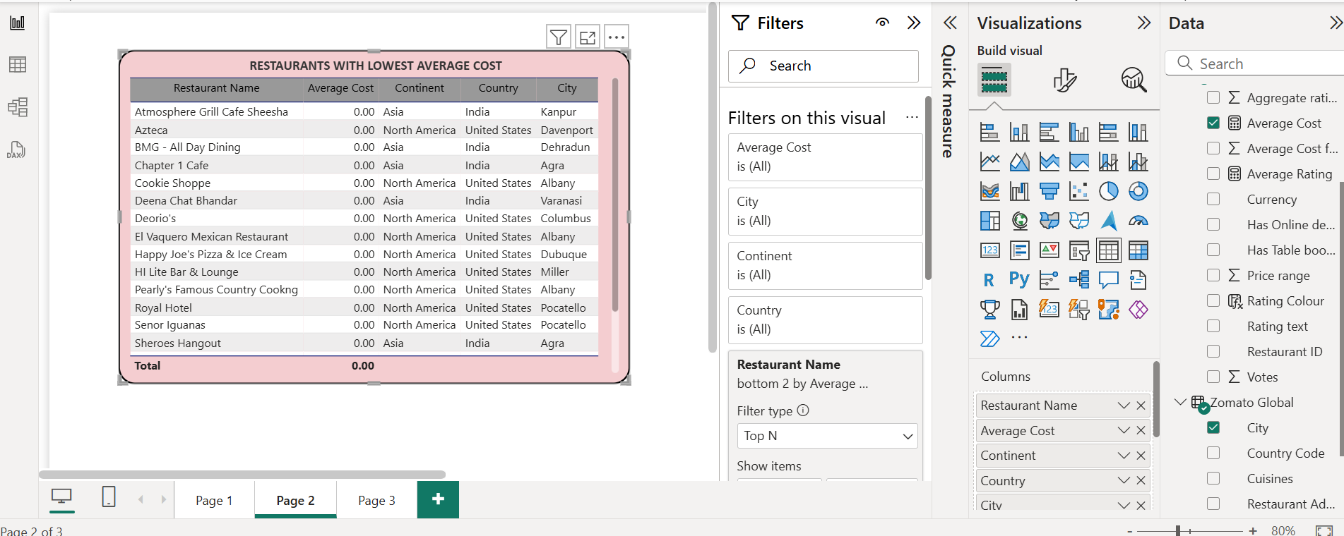

* Filter and view information on the restaurants based on :

Geographical dimensions such as continent, country, and city & Services provided such as online ordering or reservation services.

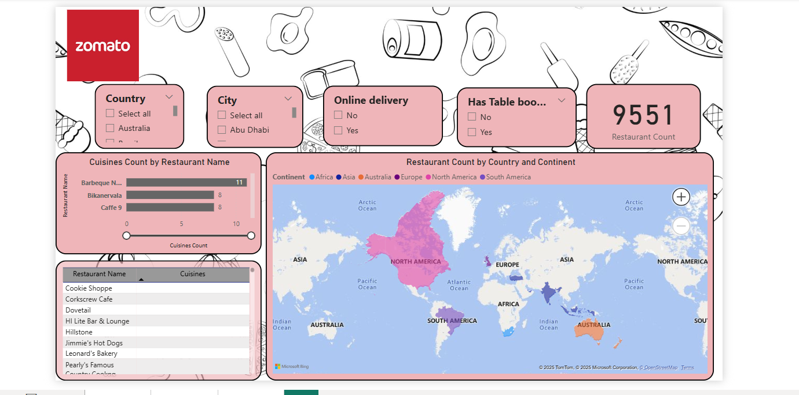

* Average Rating by colour

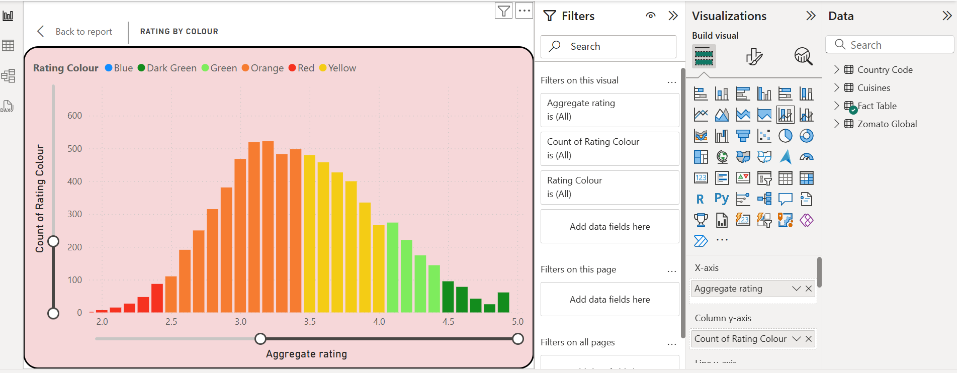

* Restaurants with most served cuisines

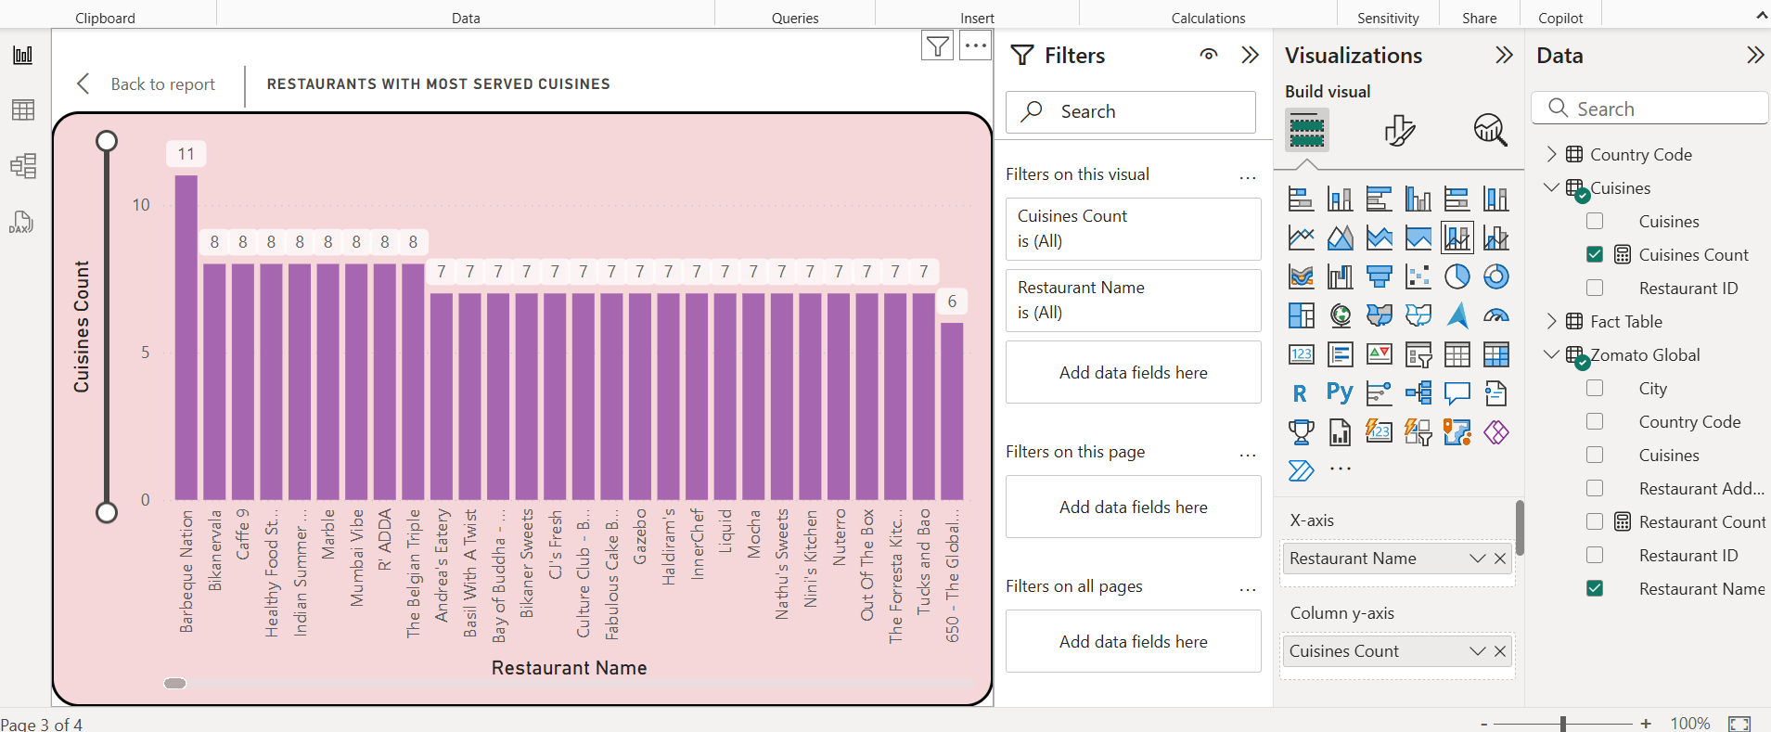

* Multi-page report as per Zomato's theme with easy navigation across sections :

PAGE 1 –

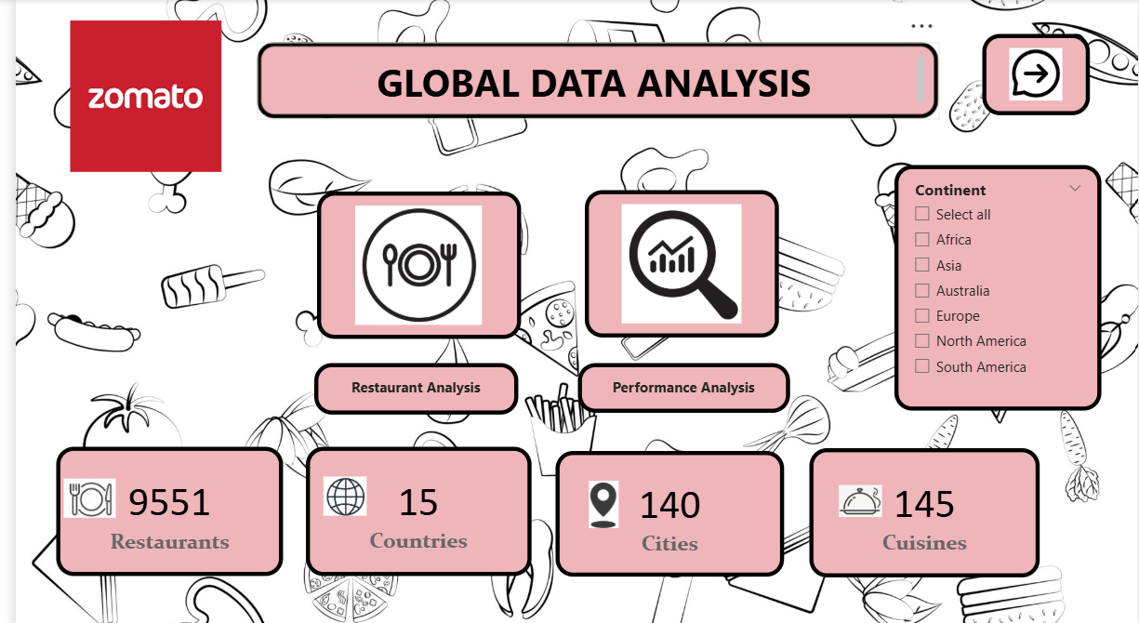

PAGE 2 –

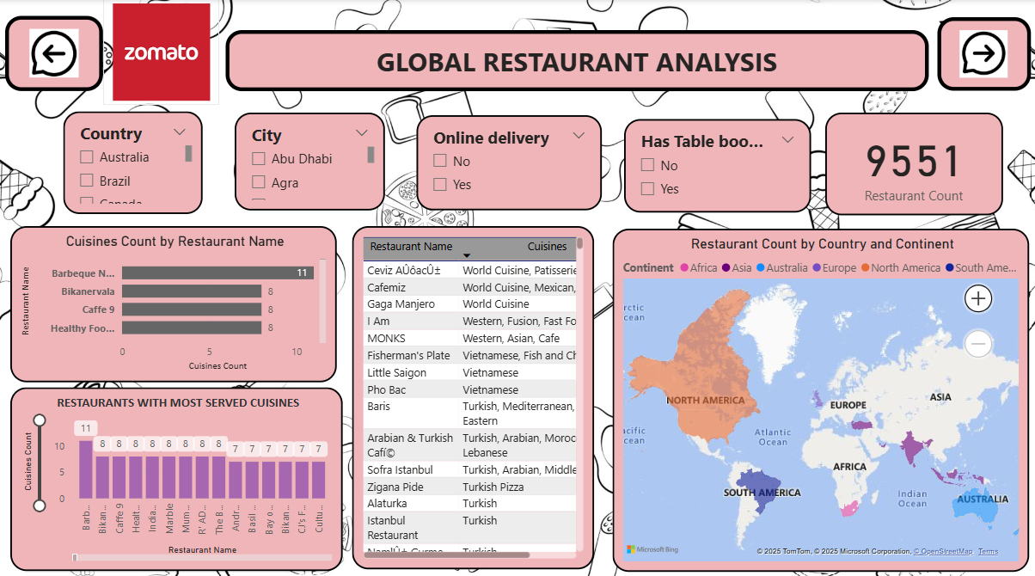

PAGE 3 –

